Assignment 4
Name: Digvijay Vikas Sawant
PRN: 260240125023
1. List all **meta characters used in the Linux shell** and explain their purpose with examples.
Meta Character | Purpose | Example
* | Matches zero or more characters | ls *.txt lists all .txt files
? | Matches exactly one character | ls file?.log matches file1.log, fileA.log
[ ] | Matches any one character within brackets | ls [abc]* matches files starting with a, b, or c
[a-z] | Matches any character in the specified range | ls [0-9]*.txt matches files starting with a digit
[^...] or ! | Negates the character set | ls [^a-z]* matches files not starting with lowercase letters
> | Redirects stdout to a file (overwrite) | ls > output.txt saves output to file
>> | Redirects stdout to a file (append) | date >> log.txt appends current date
< | Redirects input from a file | sort < input.txt sorts content of file
& | Runs command in background | sleep 60 & runs sleep in background
&& | Logical AND: runs second command only if first succeeds | mkdir test && cd test
|| | Logical OR: runs second command only if first fails | command1 || echo "Failed"
; | Separates multiple commands on same line | cmd1 ; cmd2 runs both regardless of outcome
$() | Command substitution | echo "Today is $(date)"
$ | Variable expansion | echo $HOME prints home directory path
\ | Escapes special meaning of next character | echo \$HOME prints literal "$HOME"

2. Write a command that uses the **wildcard `*`** to list all `.txt` files in a directory.
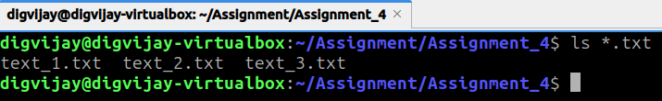
3. Write a command that uses the **wildcard `?`** to list files that have exactly five characters in their name.
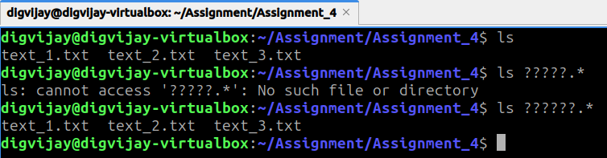
4. Demonstrate **output redirection** by sending the output of `ls` into a file named `filelist.txt`.
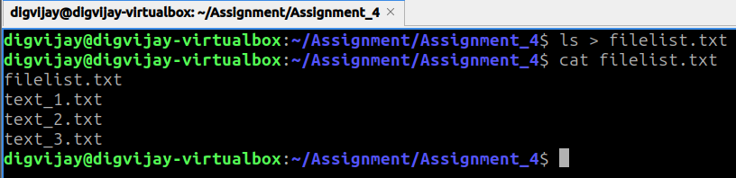
5. Write a command that **appends output** of the `date` command to a file called `log.txt`.
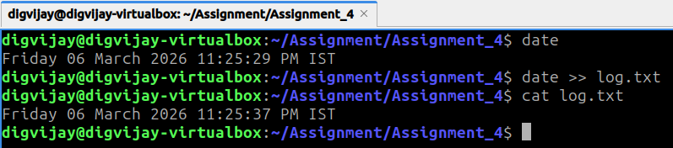

6. Show how to **pipe (`|`) the output of `ls` into the `grep` command** to find files containing the word `test`.
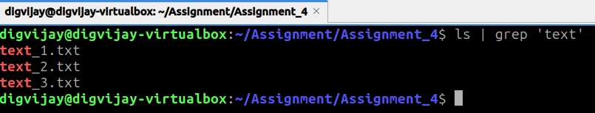
7. Write a command that uses **command substitution `$()`** to display the current date inside an echo statement. 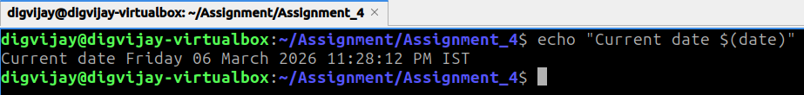
8. Demonstrate how to use **logical operator `&&`** to run two commands only if the first command succeeds.
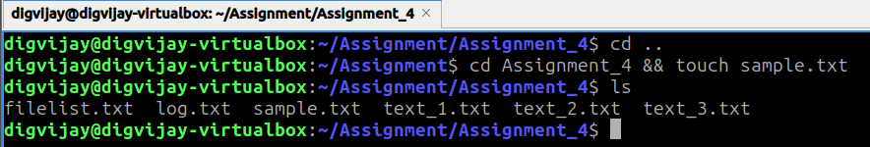
9. Write a command that runs `sleep 60` in the **background**.
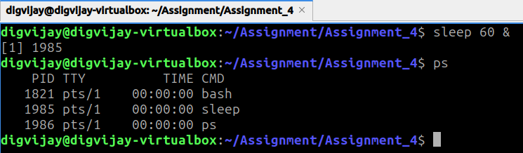
10. Show the command used to **list all background jobs** currently running in the shell.
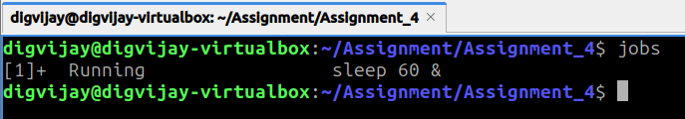

11. Write a command to **bring a background job to the foreground**.
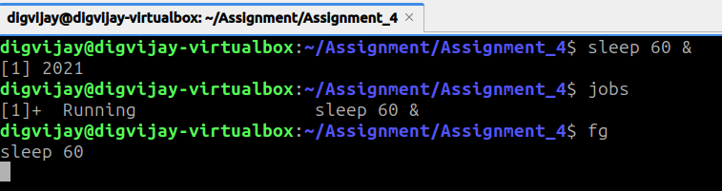
12. Display the **last 10 commands executed in the shell** using the history command.
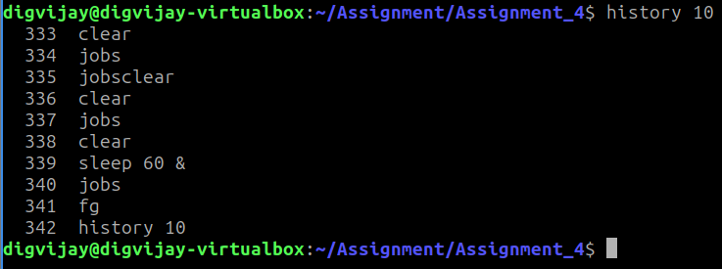
13. Write a command to **execute the last command again** using shell history.
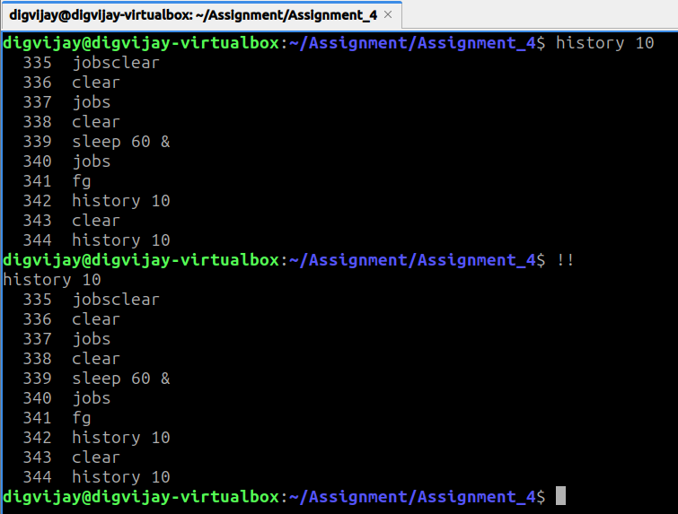

14. Execute the **5th command from command history** using the appropriate syntax.
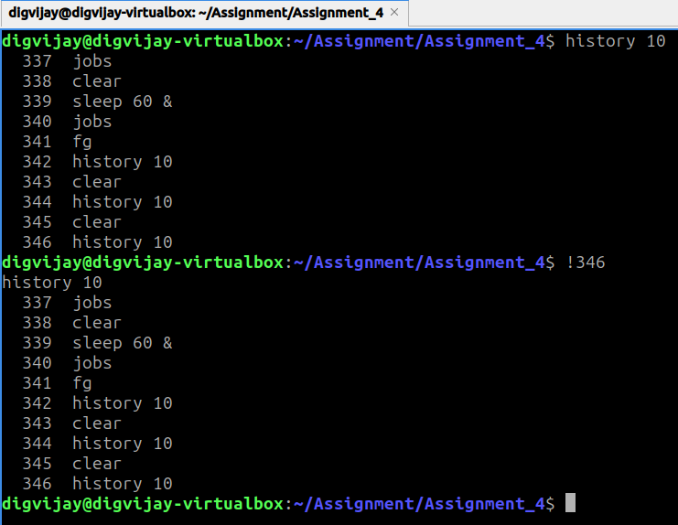
15. Create a file named **example.txt** and change its ownership to user `user1`.
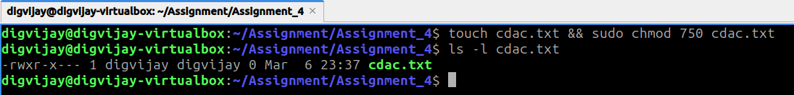
16. Write a command to change the **owner and group** of `example.txt` to `user1` and `group1`.
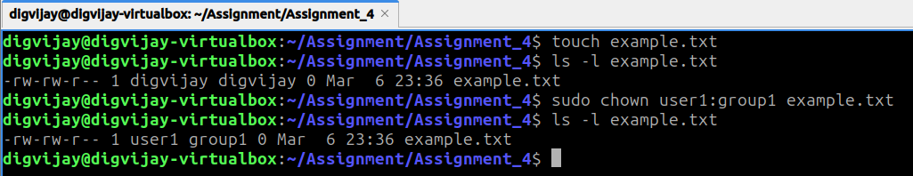

17. Create a file named **cdac.txt** and assign permissions such that the **owner has rwx, group has rx, and others have no permissions**.

18. Write a command to **view the Access Control List (ACL)** of a file named `file1`.
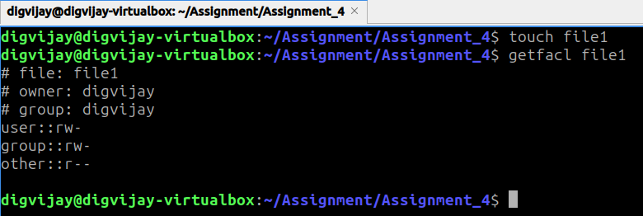
19. Write a command to **give user `user2` read and write permissions** on `file1` using ACL.
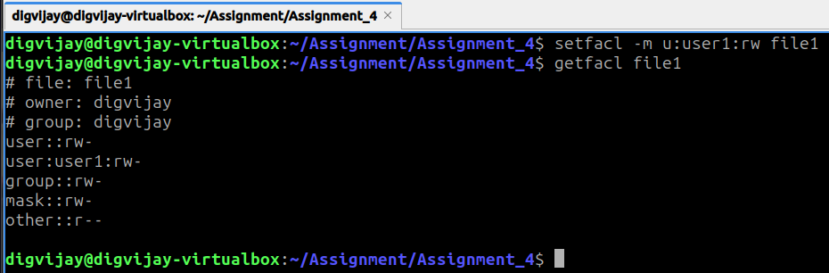
20. Write a command to **remove ACL permissions for user `user2`** from `file1`.
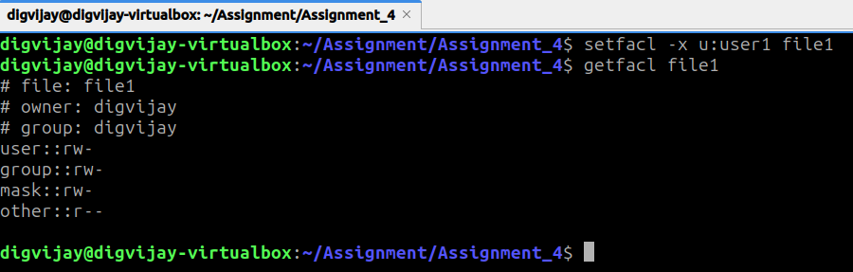

21. Write a command to **mount a filesystem from `/dev/sdb1` to `/mnt/external`**.
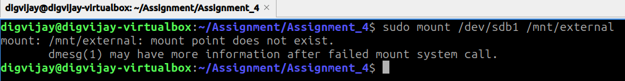
22. Write a command to **unmount a mounted filesystem from `/mnt/external`**.
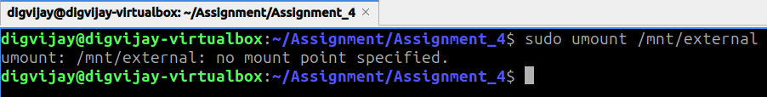
23. Use `grep` to **search for the word "linux" in file.txt ignoring case sensitivity**.
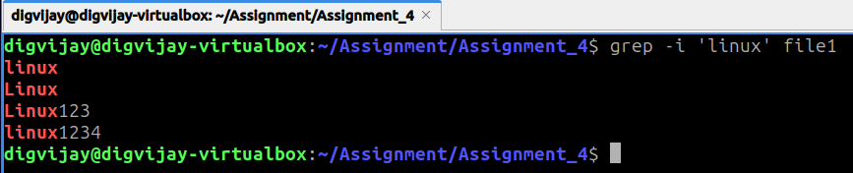
24. Write a `grep` command to **count how many times the word "error" appears in a file**.
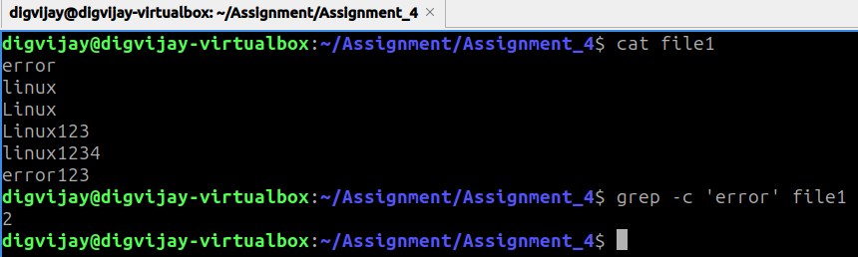
25. Write a `find` command to **locate all `.txt` files in the current directory and its subdirectories**.
